Understanding Coding
Course Code and title | Understanding Coding (Python)
Units Covered | Python
Task Title | Sorting Algorithms
Author | Komal Karir
Date Issued | 8th September 2025
Date Due | 15th September 2025

Learner’s Statement
All work submitted in your portfolio must be your own.

If you copy from AI tools, somebody else or allow another candidate to copy from you then you may be disqualified.

I have read and understood the Notice for Candidates

I confirm:

- This submission is my own work
b) Any help from others, excluding the tutor(s), has been explained below.

Learner’s Name: | Michael Everett
Date Submitted

Description of Algorithm with Sample Data:

Bubble sorting works by running through an array of values, comparing each one and (depending on whether you're sorting from smallest to largest or vice versa) either leaving it as be if the value is smaller, or swapping it if the value is larger. The function then iterates through the array, repeating the process, until it's been done for each value.

Say we have 5 numbers in an array [18, 16, 4, 39, 26]

Take the first value, 18 – is it higher than 16? Yes, so we swap it -> [16, 18, 4, 39, 26]
Is 18 higher than 4? Yes, so we swap it -> [16, 4, 18, 39, 26]
Is 18 higher than 39? No, so we don’t swap it.

We then move one value up – is 39 higher than 26? Yes, so we swap it -> [16, 4, 18, 26, 39]

As we are at the end, we go back to the start and loop through again, starting with the number 16, repeating the process for the number of times equivalent to the number of values in the array.

Python Code: Please paste your Python code in the box below.
# Paste your code here
# ==================================================
# Sorting algorithm
# NCFE Level 2 certificate homework
# Michael Everett
# ==================================================

# Bubble Sort

# Bubble sorting works by running through an array of values, comparing each one and (depending on whether you're sorting from smallest to largest or vice versa) either leaving it as be if the value is smaller, or swapping it if the value is larger. The function then iterates through the array, repeating the process, until it's been done for each value.

import random as rd

listLength = int(input("Choose a number between 0 and 20. A list will be generated with that amount of numbers and then sorted. "))
userList = []

for x in range(listLength) : # Generating a list this way allows for more thorough testing without the need to change the array in the program each time
userList.append(rd.randint(1, 99))

print(userList) # Check the unsorted list, on the off chance it comes pre-sorted during testing
# print(listLength)

for i in range(listLength) :
for j in range(listLength - i - 1) :
# print(userList)
if userList[j] > userList[j + 1] :
userList[j], userList[j + 1] = userList[j + 1], userList[j]

# This method of sorting can actually be slightly improved by adding a boolean value to check whether or not each number has been swapped as it iterates through, and breaking the sequence each time the number isn't swapped; the version above is the more basic version of the bubble sort.

print(userList)

Evdence of Testing

Please paste screen shots or screen snippets as evidence of testing and test results.

Include comments to describe the screen image.

===================================================

Initial screen upon running program:
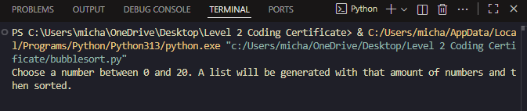

When creating a list with 10 random numbers:
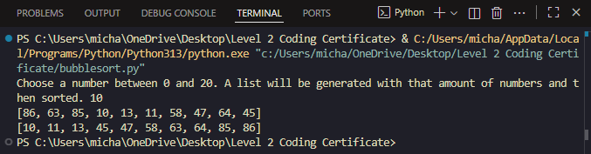

When N = 0:
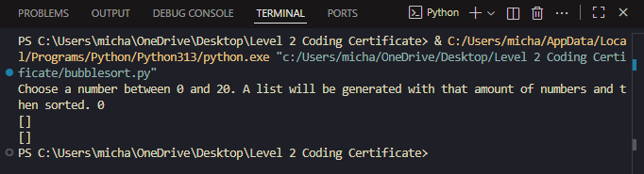

When N = 1:
